**SANKET KHOT**

DOMAIN - E COMMERCE

**ANALYSING**

**AMAZON**

**SALES DATA**

**Introduction**

PROBLEM STATEMENT

Amazon, a global e-commerce and technology giant, pioneers convenience and innovation. From retail to cloud computing, it transforms industries, prioritizing customer-centric solutions, and shaping the future of online commerce.

Sales management has gained importance to meet increasing competition and the need for improved methods of distribution to reduce cost and to increase profits. Sales management today is the most important function in a commercial and business enterprise.

**Details of Data**

**1. Top 5 Gross Profit Margin Categories:**

1.**COSMETICS**

Dominates with the highest profit margin, reflecting customer preference.

Strong correlation between high sales and priority.

2.**HOUSEHOLD**

Significant profitability, especially with the most expensive item priced at 668.27.

Offline sales outperform online, indicating a traditional market preference.

3.**Office Supplies**

Consistent profitability but potential for improvement in sales.

Delivery times may impact customer decisions.

4.**Baby Food and Cereal**

Steady profit margin, indicating a stable market for these products.

1. **Most Gross Profitable Product:**

1.**COSMETICS -> 173.87 PROFIT**

Average delivery time aligns with customer expectations.

1. **Least 2 Non-Profitable Products:**

1.**FRUITS -> 2.41 PROFIT**

Despite popularity, low profitability suggests a need for pricing adjustments.

2.**BEVERAGES -> 15.66 PROFIT**

Low profit, possibly due to the cancel priority from customers.

Reevaluate marketing or consider bundling options to increase sales.

1. **Profit Margin of Products:**

1.**COSMETICS -> 173.87 PROFIT**

2.**CLOTHES -> 67.20 %**

3.**CEREAL -> 43.07 %**

4.**VEGETABLES -> 40.98 %**

5.**COSMETICS -> 39.77 %**

6.**BABY FOOD -> 37.55 %**

7.**SNACKS -> 36.14 %**

8.**BEVERAGES -> 33.00 %**

9.**PERSONAL CARE -> 30.66 %**

10.**FRUITS -> 25.83 %**

11.**HOUSEHOLD-> 24.80 %**

12.**OFFICE SUPPLIES -> 19.39 %**

13.**MEAT -> 13.56 %**

1. **Most Expensive Item:**

1.**HOUSEHOLD -> 668.27**

High-end products show potential for premium offerings.

Analyze whether premium items align with the overall customer base.

1. **Cheapest Item:**
   1. **FRUITS ->9.33**

While attracting orders, consider strategies to improve profitability.

Evaluate whether the lower margin is offset by higher sales volume.

1. **Delivery and Priority Insights:**

1.**COSMETICS DELIVERY DAYS:**

Average of 23 days aligns with high priority and popularity.

2.**FRUITS DELIVERY DAYS:**

26 DAYS DELIVERY TIME INDICATES A LONGER WAIT, AFFECTING CUSTOMER SATISFACTION.

1. **Sales Insights:**

1.**HOUSEHOLD ITEMS:**

Offline dominates, suggesting a traditional market preference.

2.**COSMETICS:**

CUSTOMERS PREFER COSMETICS PRODUCTS FROM AMAZON (ONLINE) DUE TO CONVENIENCE, VARIETY, AND RELIABILITY, ALIGNING WITH THEIR EXPECTATIONS.

1. **Regional Analysis: Most Profitable Countries**
   1. **MYANMAR AND DJIBOUTI:**

High revenue suggests potential market growth.

Understand local preferences for targeted marketing.

**Least Profitable Countries**

1.**KUWAIT, KYRGYZSTAN, NEW ZEALAND, SLOVAKIA, SYRIA:**

ANALYZE CULTURAL FACTORS IMPACTING SALES.

EXPLORE STRATEGIES TO INCREASE MARKET SHARE OR CONSIDER MARKET EXIT.

1. **Year-wise Performance:**

**Best Years:**

1.**2010, 2012, 2013, 2014**

High revenue and profit in these years.

2012 stands out with the highest number of orders (ie; 97,967), driven by personal care products.

**Worse Years:**

1.**2011, 2015, 2016, 2017**

Lowest revenue and profit, with 2011 is particularly challenging.

1. **Product Category Insights:**

**Most Sold :**

* 1. **COSMETICS**

Understand customer preferences to optimize marketing.

Consider bundling options to boost sales in less popular categories.

**Least Sold:**

1.**MEAT**

ANALYZE IF CUSTOMER AVERSION TO MEAT PRODUCTS IS DUE TO QUALITY, CULTURAL FACTORS OR DUE TO LOCAL MARKET PURCHASING SATISFACTION.

EVALUATE THE FEASIBILITY OF MAINTAINING THIS CATEGORY.

1. **Customer Preferences:**

**High Priority:**

1.**COSMETICS, BABY FOOD, CEREAL, HOUSEHOLD.**

**Least Priority:**

1.BEVERAGES, FRUITS.

1. **Online vs. Offline Preferences:**

CUSTOMERS PREFER TO PURCHASE HOUSEHOLD ITEMS OFFLINE.

COSMETIC PRODUCTS ARE MORE POPULAR ONLINE.

1. **Monthly Trends:**

**Most Orders:**

* 1. **MAY, JULY, OCTOBER, NOVEMBER:**

Highest order of volumes during these months.

**Least Orders:**

1.**JANUARY, MARCH, JUNE, AUGUST, SEPTEMBER, DECEMBER:**

LOWER ORDER OF VOLUMES DURING THESE MONTHS.

1. **Regional Performance Insights:**

**Asia**

Highest revenue; prioritize marketing strategies for cosmetics and clothes.

**Australia and Oceania**

Beverage sales benefit from the hot climate; consider expanding product lines.

**Most Sold Item: Beverages**

**Least Sold Item: Cereal**

Reasoning: Beverages align with the region's hot climate, driving higher sales. Cereal, being less suited to the climate, sees lower demand.

**Central America and Caribbean**

Focus on improving sales in the cosmetic category.

**Most Sold Item: Household**

**Least Sold Item: Cosmetics**

Reasoning: The preference for household items in this region is attributed to the traditional market. Cosmetic sales could improve with targeted marketing strategies.

**Europe, Middle East and North Africa**

Explore opportunities in the oil and gas industry for office supplies.

**Most Sold Item: Cosmetics**

**Least Sold Item: Office Supplies**

Reasoning: Cosmetics have a higher demand, possibly driven by cultural preferences. Office supplies might have lower sales due to the region's focus on the oil and gas industry.

**Sub-Saharan Africa**

Adapt product offerings to suit hot climates; diversify beyond low-margin fruits.

**Most Sold Item: Fruits**

**Least Sold Item: Meat**

Reasoning: Fruits align with the region's hot climate, driving sales. Meat has lower demand, possibly due to climate influences and local dietary preferences.

**North America**

**Most Sold Item: Personal Care**

**Least Sold Item: Household**

Reasoning: Generally dry with cold winters and hot summers drive high demand for personal care items.

# Main KPIs

**TOTAL REVENUE -** 137348768.31

**TOTAL ITEMS SOLD -** 12

**MOST SOLD ITEMS BY SALES MODE (OFFLINE)-** HOUSEHOLD , UNIT SOLD - 44445

**MOST SOLD ITEMS BY SALES MODE (ONLINE)-** COSMETICS , UNIT SOLD - 41969

**LEAST SOLD ITEMS BY SALES MODE (OFFLINE)-** CEREAL , UNIT SOLD - 3761

**LEAST SOLD ITEMS BY SALES MODE (ONLINE)-** HOUSEHOLD , UNIT SOLD - 282

**MOST EXPENSIVE ITEM -** HOUSEHOLD , PRICE - 668.27

**CHEAPEST ITEM -** FRUITS , PRICE - 9.33

**TOP 3 MOST SOLD ITEMS THROUGHOUT AMAZON SALES -**  COSMETICS , CLOTHES AND BEVERAGES

**3 LEAST SOLD ITEMS THROUGHOUT AMAZON SALES -** MEAT, SNACKS AND VEGETABLES

**MOST GROSS PROFIT MARGIN ITEM -** COSMETICS (PROFIT -173.87)

**LEAST GROSS PROFIT MARGIN ITEM -** FRUITS (PROFIT -2.41)

# Mock – up Dashboard

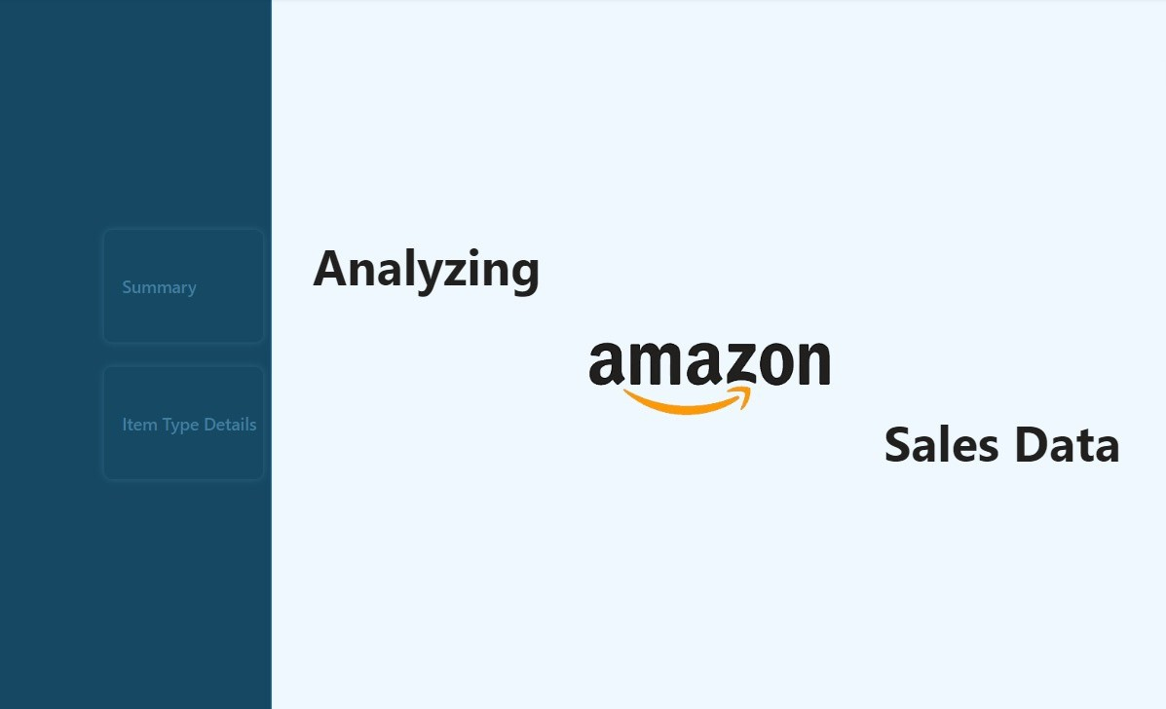

# MY DESIGN

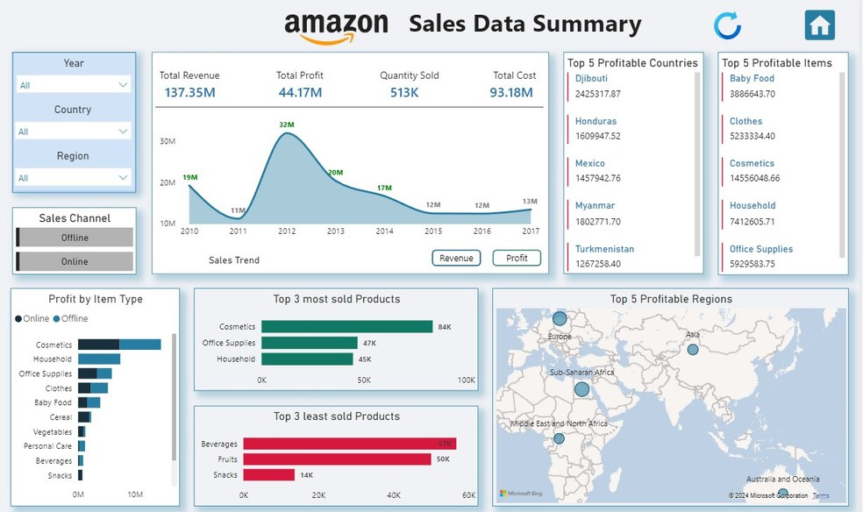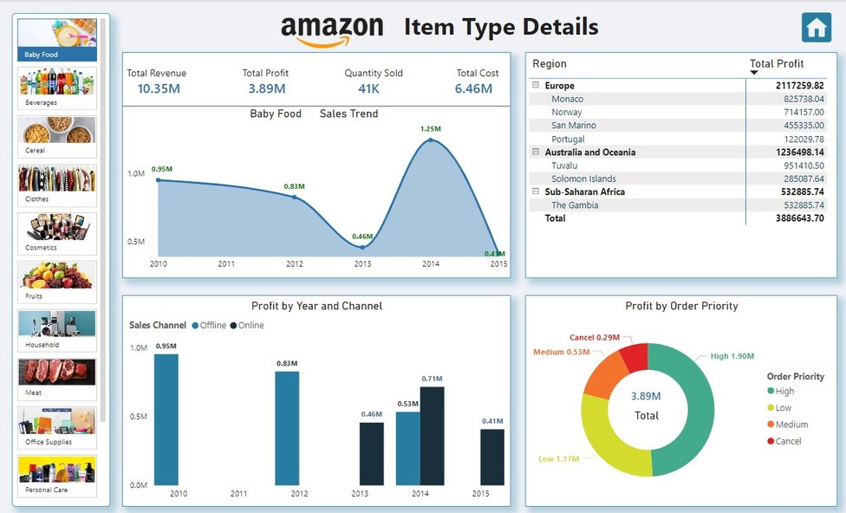

# THANK YOU